Order Of Service

Singing: Psalm 32—CW page 78

Reading:

Opening Hymn:

Reading:

Request Hymn: CW Supplement

Reading:

Sermon Hymn:

Sermon Text:

Perfect Peace

Prayer

The Apostles’ Creed, TLH page 12

Holy Communion

The Lord's Prayer

The Blessing

Closing Hymn:

************

Bible Study: Lambs:
Sheep:
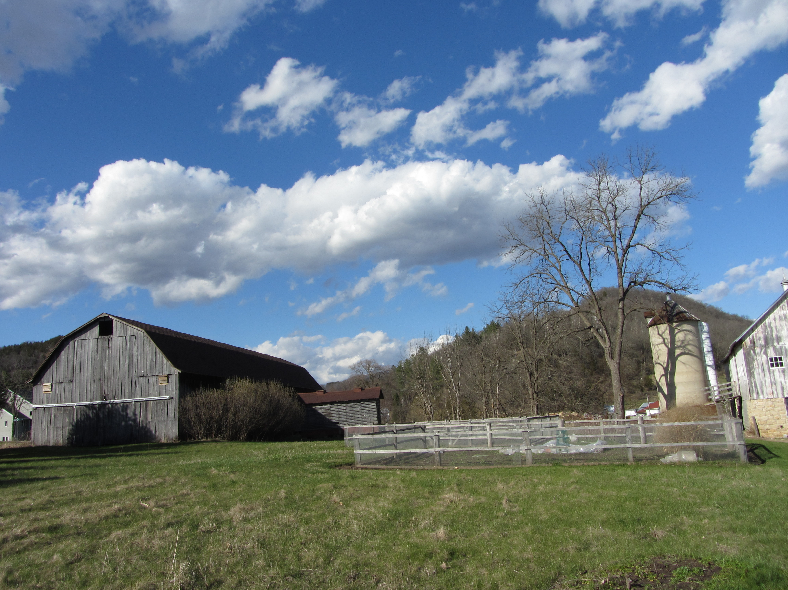

Water
Of
Life

17 April 2024

W A T E R O F L I F E

Independent Christian Church—Conservative Lutheran Doctrine

Worship Service: 9:30 a.m.

Larry Cooper, Pastor E-Mail address:
lcooper@wateroflife.cc
Web Site:
www.wateroflife.cc

* * * * * * * * * * * * * * * * * * * * * * * * * * *

Sermon Text: TBA

The Big Surprise

* * * * * * * * * * * * * * * * * * * * * * * * * * *

